1. Development Steps:
- First, I created a Splash Screen that automatically redirects the user to the Login screen after a few seconds.
- I set up the Express.js backend, connected it with a live MongoDB database, and configured Cloudinary for storing uploaded images.
- After that, I developed the Login and Signup screens and connected them with the backend APIs.
- I created the Create Story screen where users can select an image from their phone gallery and upload it.
- To keep the code organized and easier to manage, I separated the Create Story screen into smaller reusable components such as TopControls and BottomControls.
- I then developed the Story Viewer screen, which displays uploaded stories in full-screen mode using ImageBackground.
- Finally, I implemented story navigation so users can move between stories by tapping on the screen, and the application automatically opens the next user's stories when the current stories finish.
2. AI Interaction Record:
1:
I asked AI: How to automatically move from splash screen to login screen after some time?
AI gave code.
AI suggested using a combination of useEffect and setTimeout. I implemented this approach and successfully navigated the user to the Login screen after a short delay.
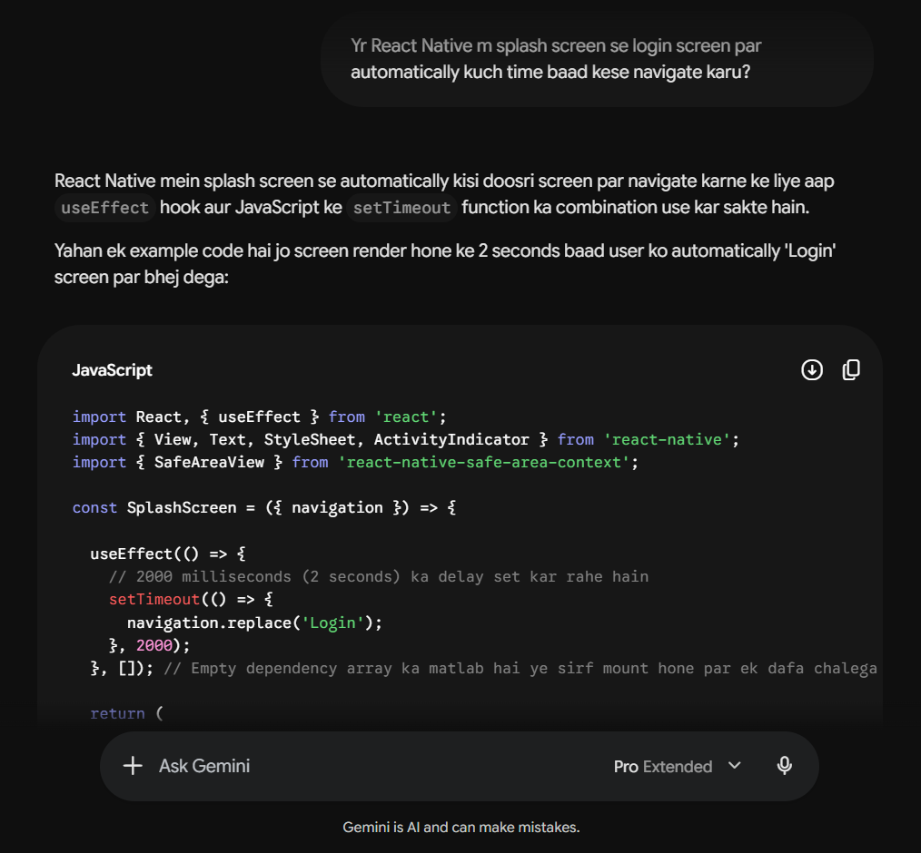
2:
I asked AI: How to make the backend live with MongoDB and handle multer storage?
AI gave code.
AI explained how to configure MongoDB and multer. While deploying the backend on Vercel, I spent some time debugging image upload errors before realizing that local file storage was not persistent. After understanding the issue, I switched to Cloudinary for storing uploaded images permanently.
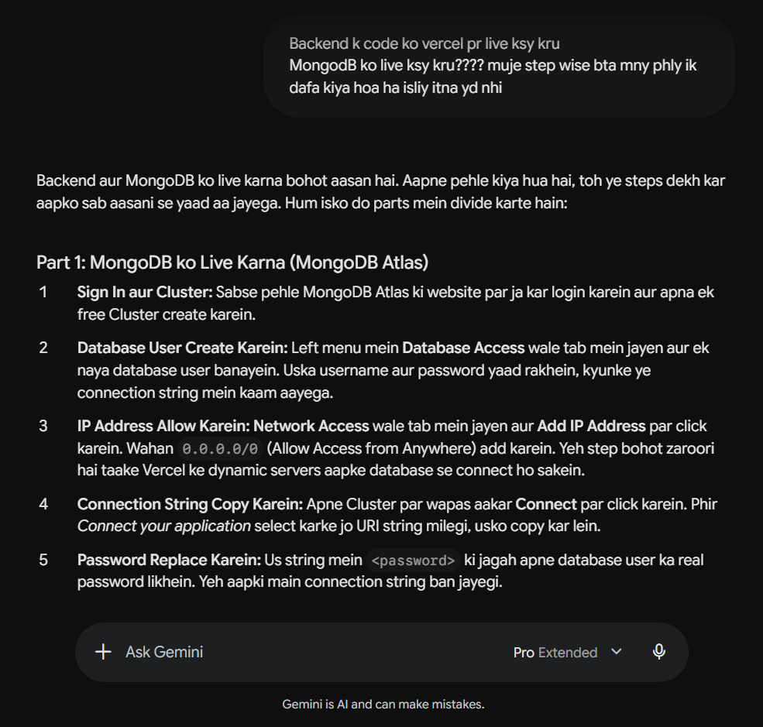

3:
I asked AI: How to connect the login screen to the backend?
AI gave code.
AI provided an example using Axios. I modified the code according to my project and used axios.post to send user credentials and receive the authentication token.
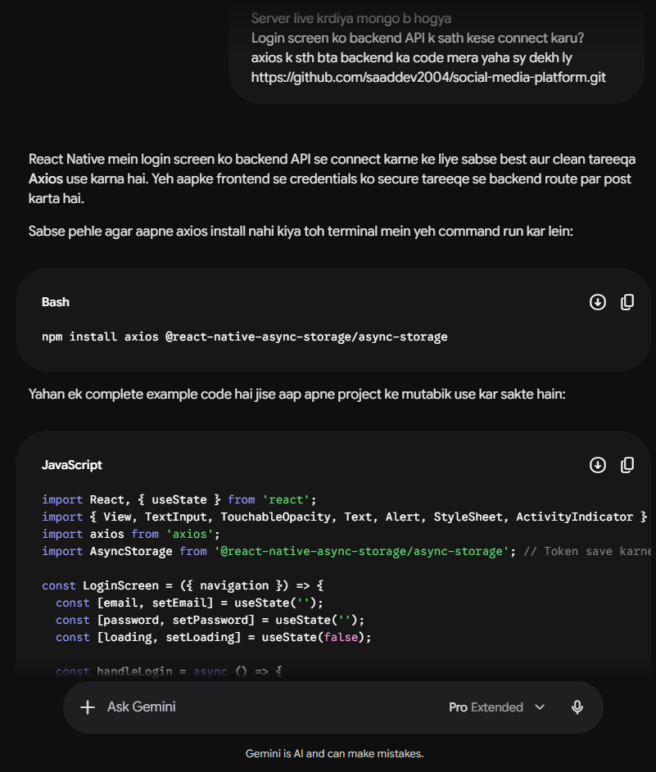
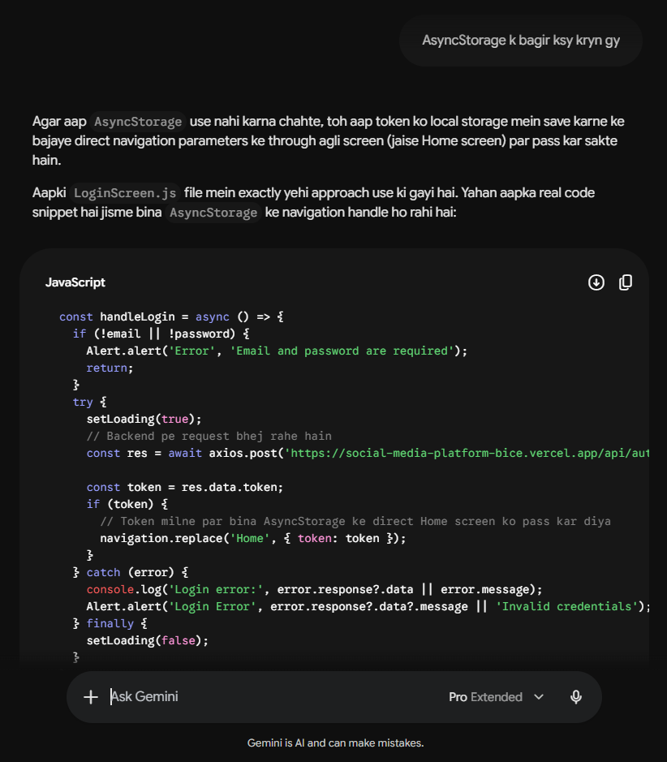
4:
I asked AI: How to send data from the Signup screen to the backend?
AI gave code.
I used the provided Axios example and connected the form fields with backend routes to register new users.
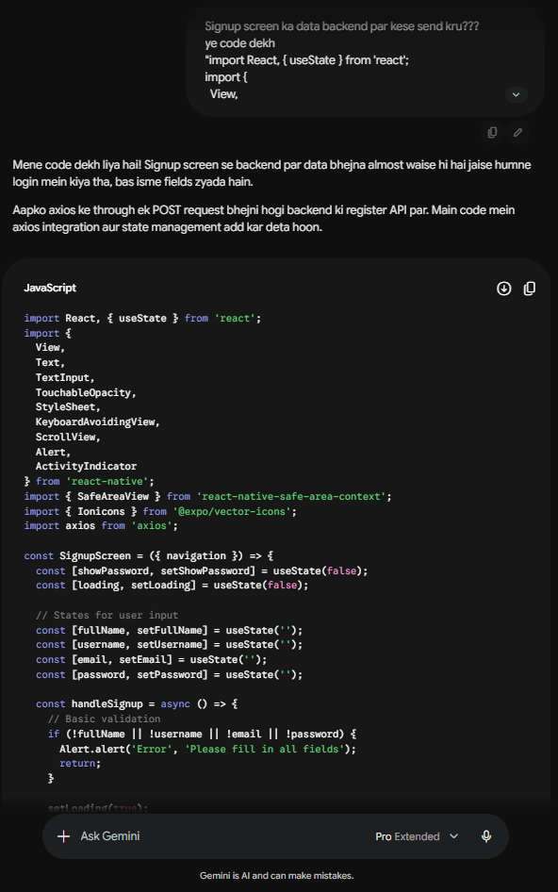

5:
I asked AI: How to pick an image from the phone gallery in React Native?
AI gave code.
AI recommended expo-image-picker. I installed the package and used it to allow users to choose images from their device gallery.
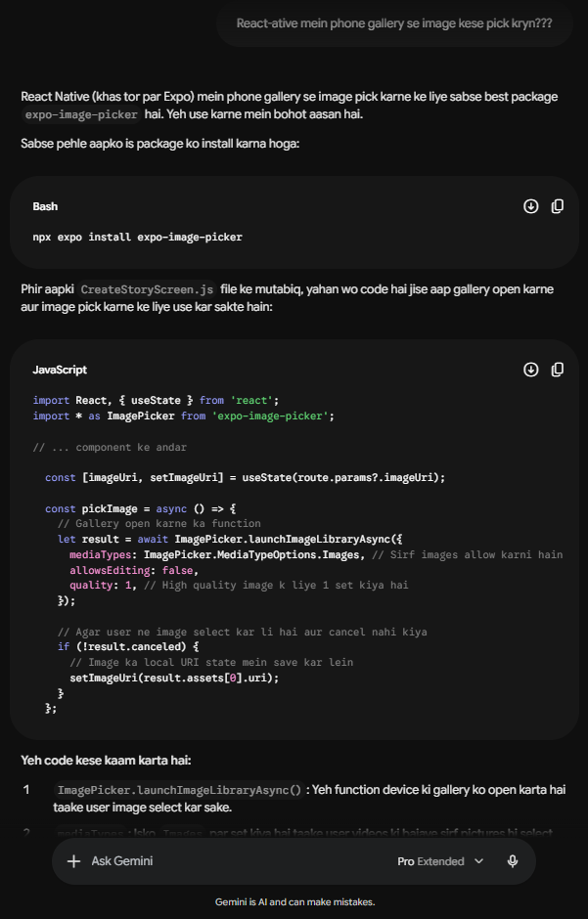

6:
I asked AI: How to send the picked image to the backend?
AI gave code.
Initially, I was unsure how image files were sent through API requests. AI explained the use of FormData, and after implementing it, I was able to upload images successfully.
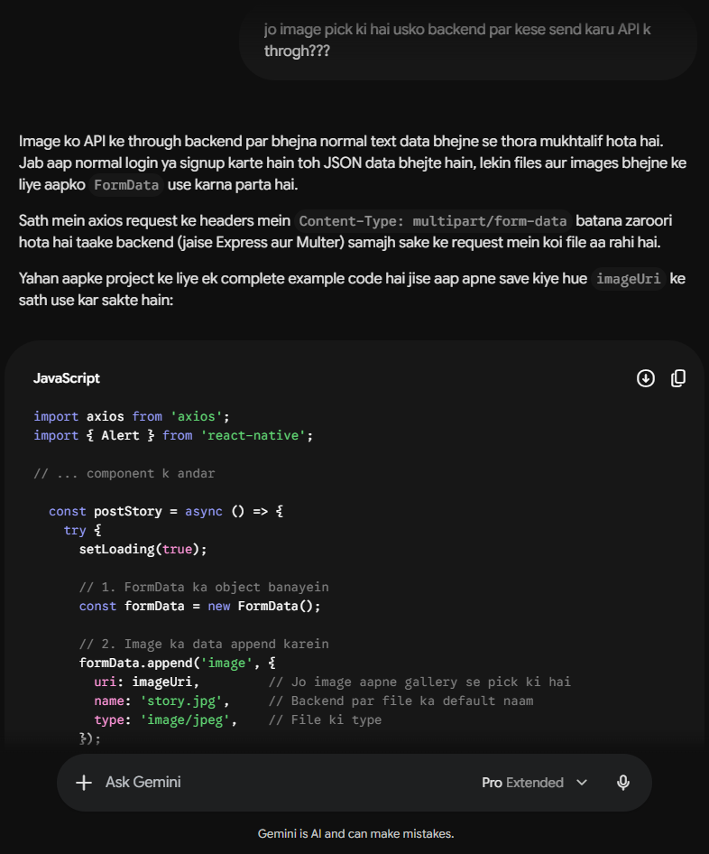

7:
I asked AI: How to show the image in full screen as a background?
AI gave code.
AI suggested using ImageBackground. I applied this component in the Story Viewer screen to display stories in a full-screen format.
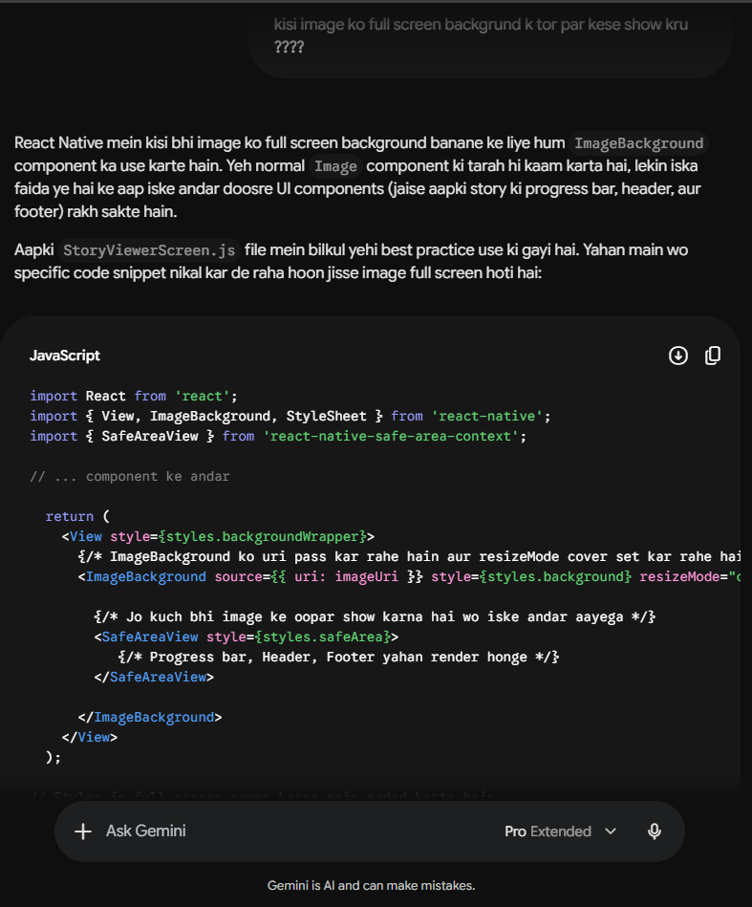
8:
I asked AI: How to separate components and pass callback functions to them?
AI gave code.
I created separate files for reusable UI sections such as TopControls and BottomControls. I also used AI suggestions to select suitable Ionicons for different actions.
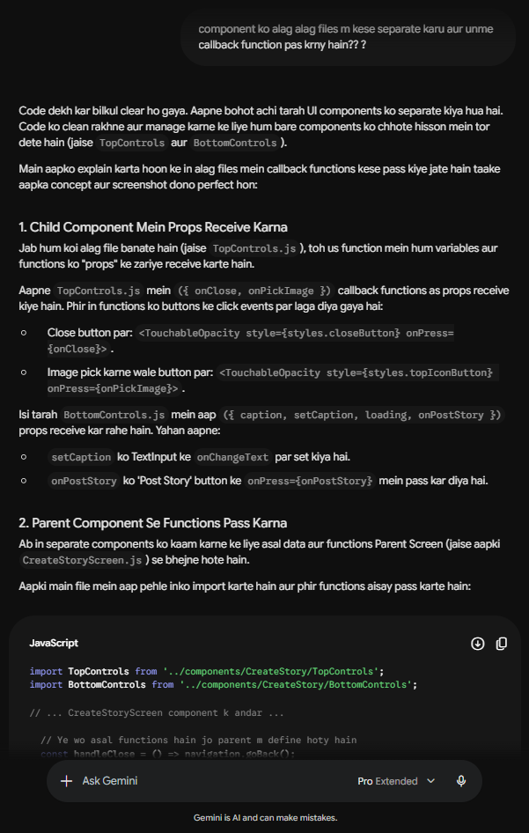
9:
I asked AI: How to convert the backend timestamp into normal time like 5m ago?
AI gave code.
AI provided a relative time function, which I integrated into my project to display story timestamps in a user-friendly format.
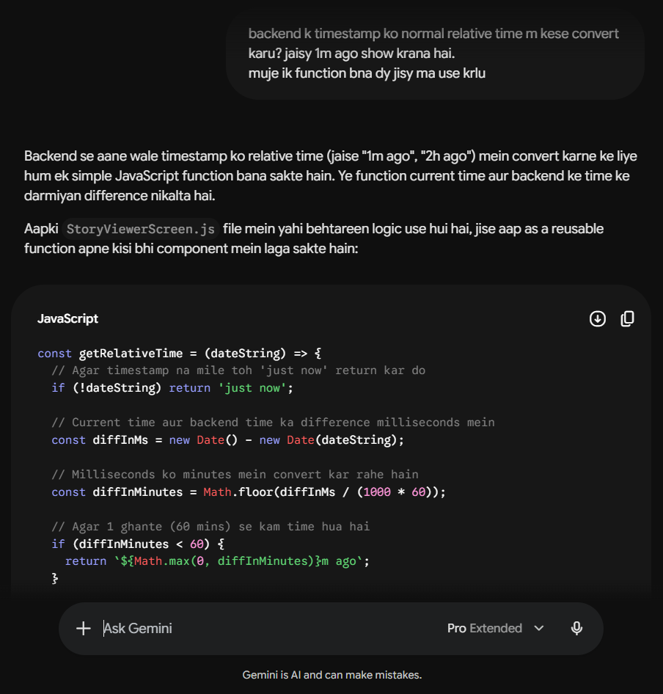
10:
I asked AI: How to move to the next story when clicking on the right side, and previous on the left?
AI gave code.
I used AI code that used the TouchableWithoutFeedback component and checked the layout coordinates (evt.nativeEvent.locationX) to decide which side was clicked.
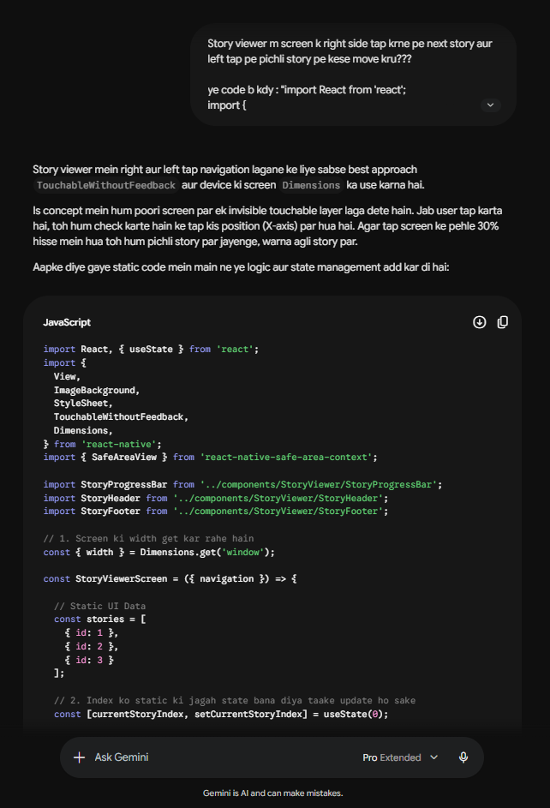
11:
I asked AI: How to show the next user's story automatically when the current user's stories end?
AI gave code.
AI provided the overall logic, and I adapted it to my story structure by updating indexes and handling transitions between different users' stories.
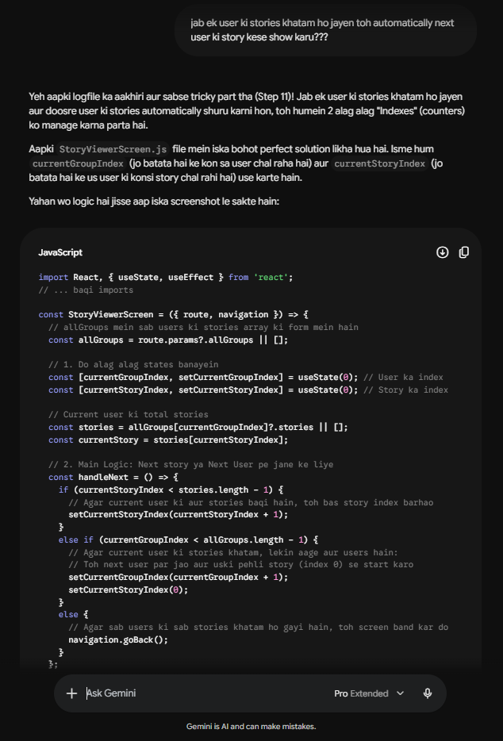

3. Problems Faced
- The Splash Screen navigation did not work correctly during the initial implementation.
- Image uploads failed after backend deployment because local storage was not persistent on Vercel.
- Understanding how frontend forms communicate with backend APIs was challenging at first.
- Passing authentication tokens and handling protected routes was confusing.
- Implementing story navigation without visible buttons required additional research and testing.
- Managing story indexes and moving between multiple users' stories was one of the most difficult parts of the project because several edge cases had to be handled correctly.

4. Solutions
- I fixed the Splash Screen issue by correctly placing setTimeout inside a useEffect hook.
- To solve image upload issues, I replaced local multer storage with Cloudinary-based storage.
- I improved my understanding of API communication by practicing Axios requests and testing endpoints.
- I learned how to send authorization headers properly when accessing protected routes.
- For story navigation, I used the tap position on the screen to determine whether the user wanted to move forward or backward.
- I carefully adjusted the story navigation logic to handle transitions between different users' story groups.

5. Learning Reflection
What I Learned: This project helped me understand how a React Native frontend communicates with a live backend and database. I learned how to use Axios for API requests, handle user authentication, upload images using FormData, and organize code into reusable components. I also gained practical experience with Cloudinary and backend deployment.
What was difficult: The most challenging part was implementing the Story Viewer logic. Managing multiple story groups, tracking indexes, and ensuring smooth navigation between stories required a lot of testing and debugging. I had to try different conditions several times before the navigation worked correctly. Understanding authentication flow and image uploads also took time because I had not worked extensively with these concepts before.

